# CS 255 System Design Document Template

*This template lays out all the different sections that you need to complete for Project Two. Each section has guidance to prompt your thinking. You will need to continually reference the interview transcript as you work to make sure that you are addressing your client’s needs. There is no required length for the final document. Instead the goal is to complete each section based on what your client’s needs are. Remove this note when you are finished, and replace all bracketed text with the relevant information.*

## UML Diagrams

### UML Use Case Diagram:

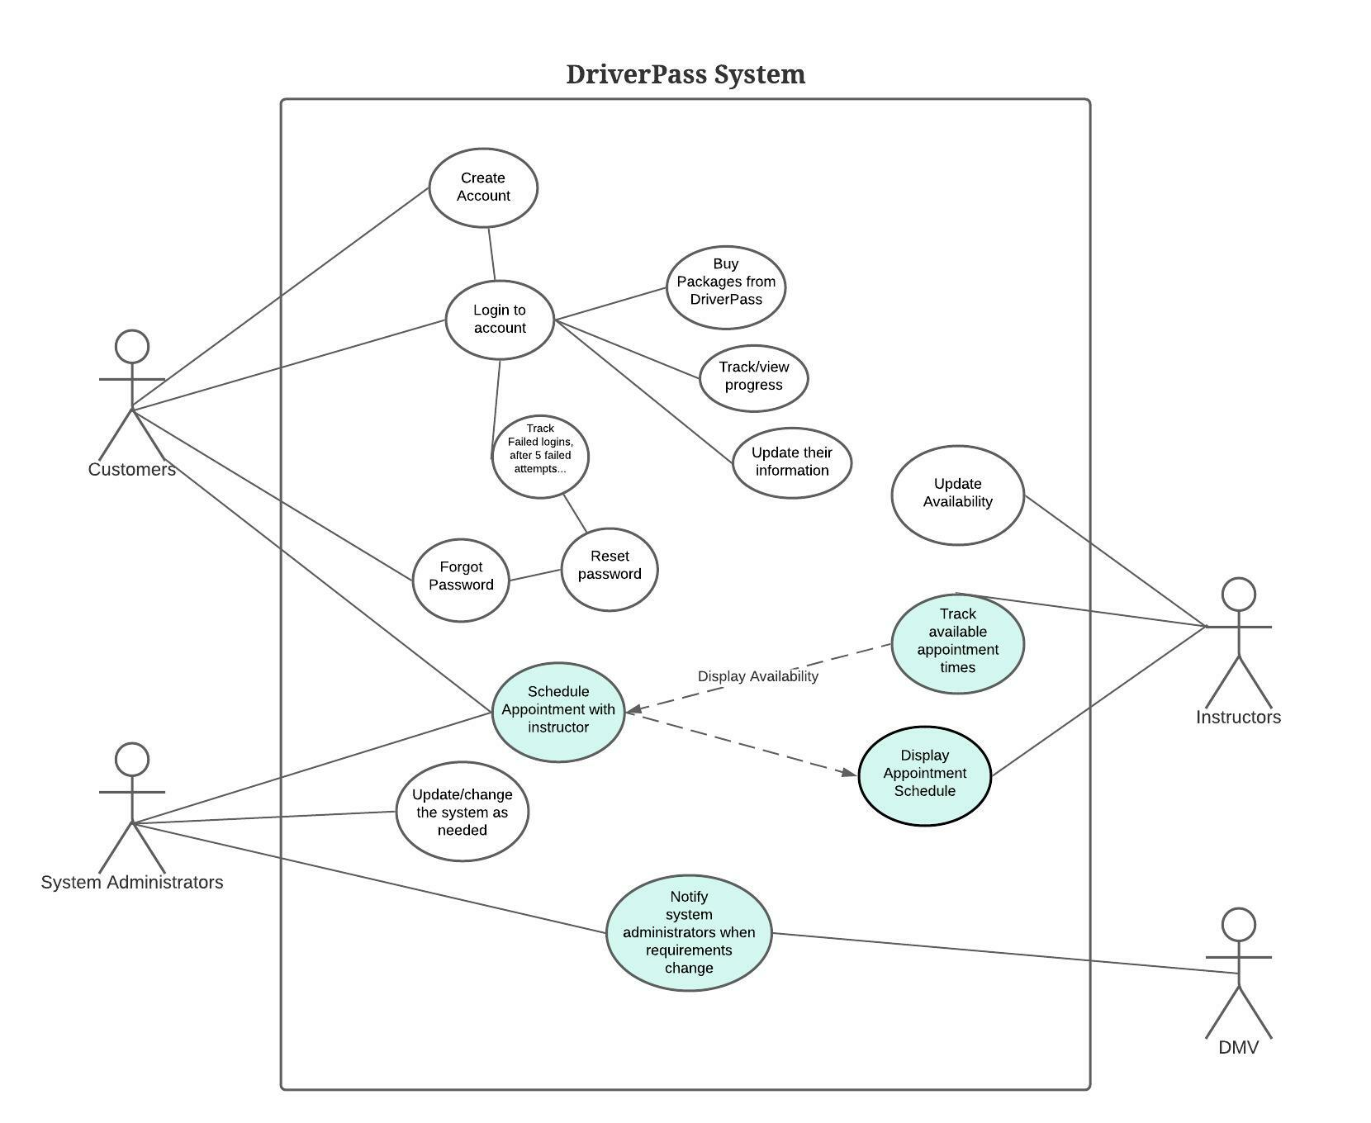

### UML Activity Diagrams:

### *User login and User schedule appointment*

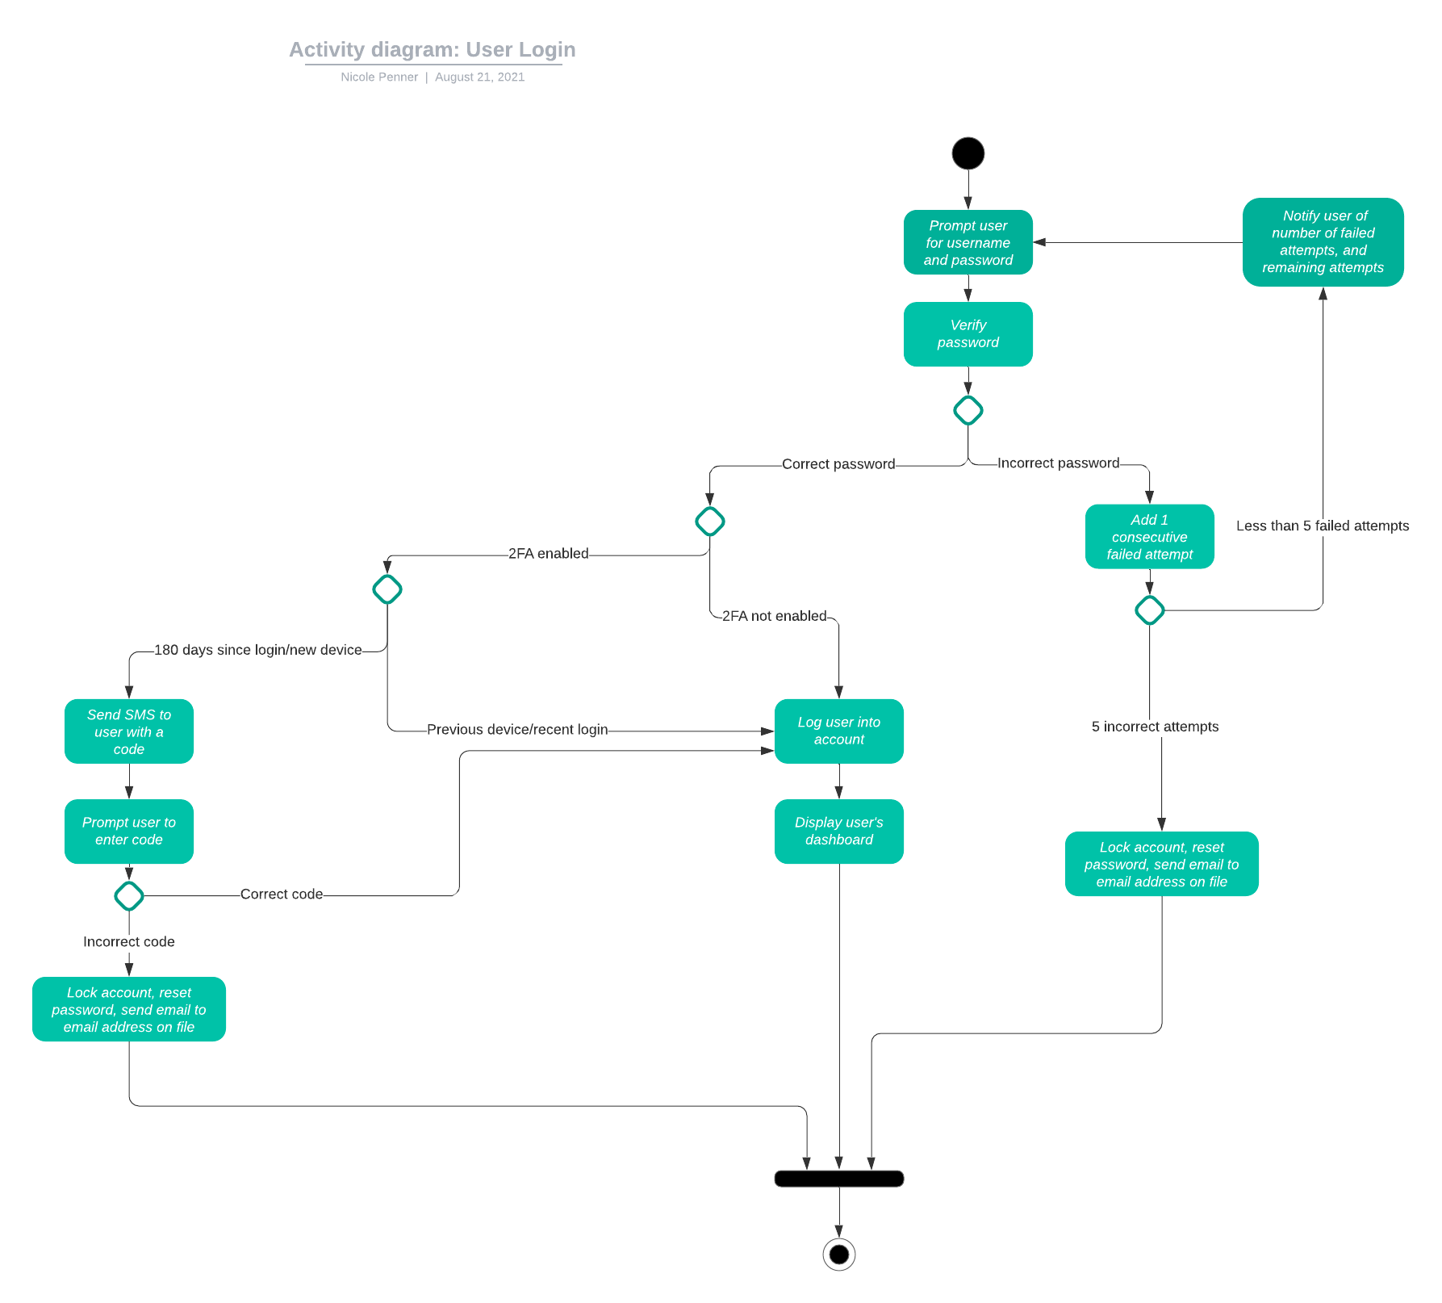

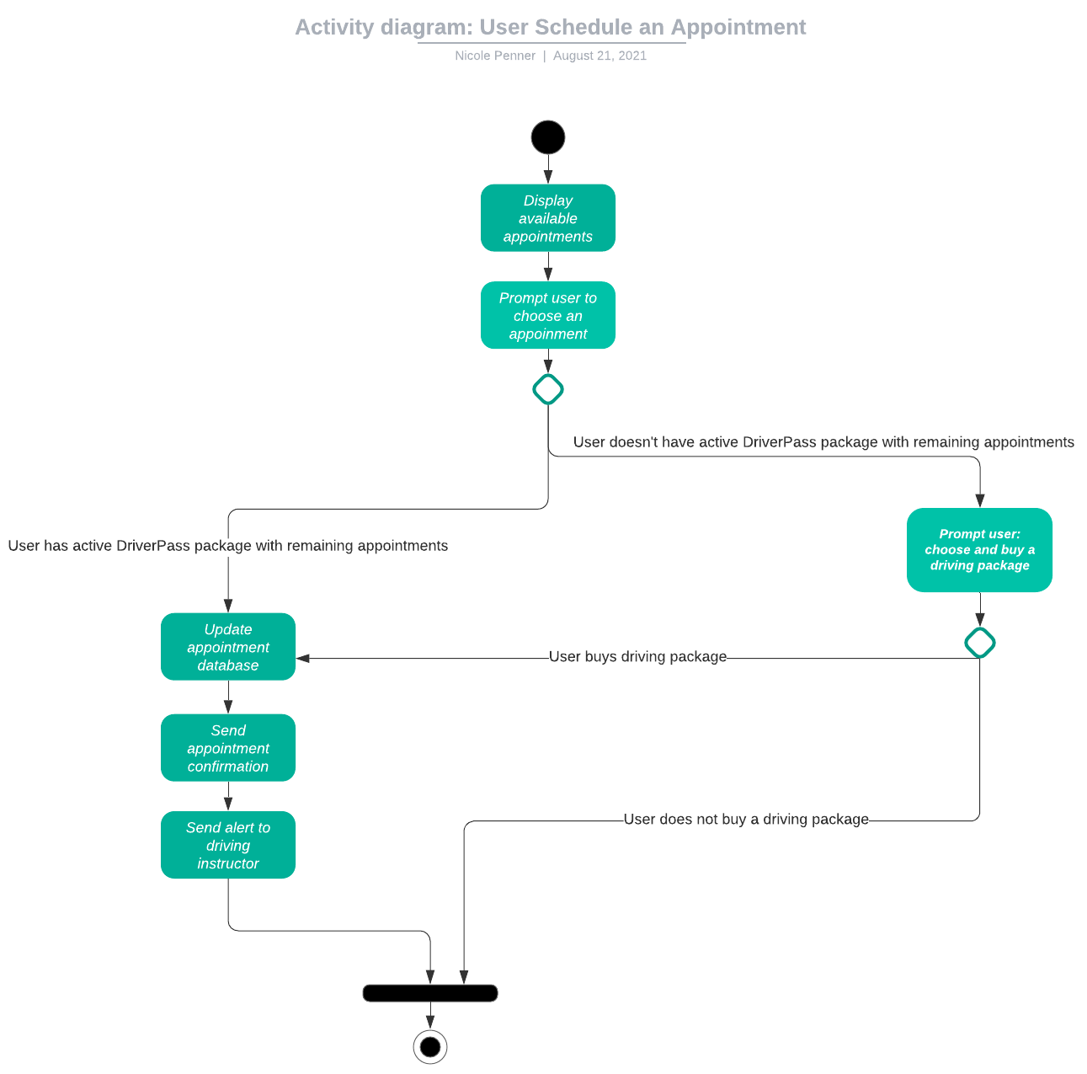

### UML Sequence Diagram:

***User schedule appointment***

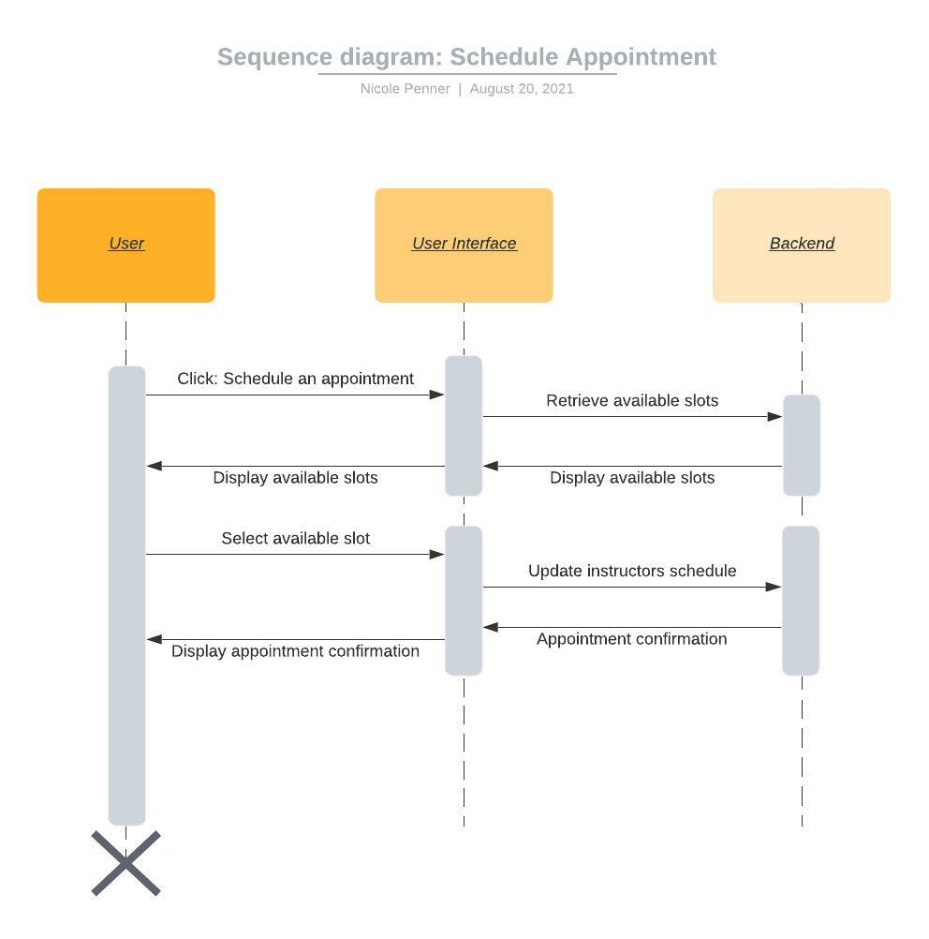

### UML Class Diagram

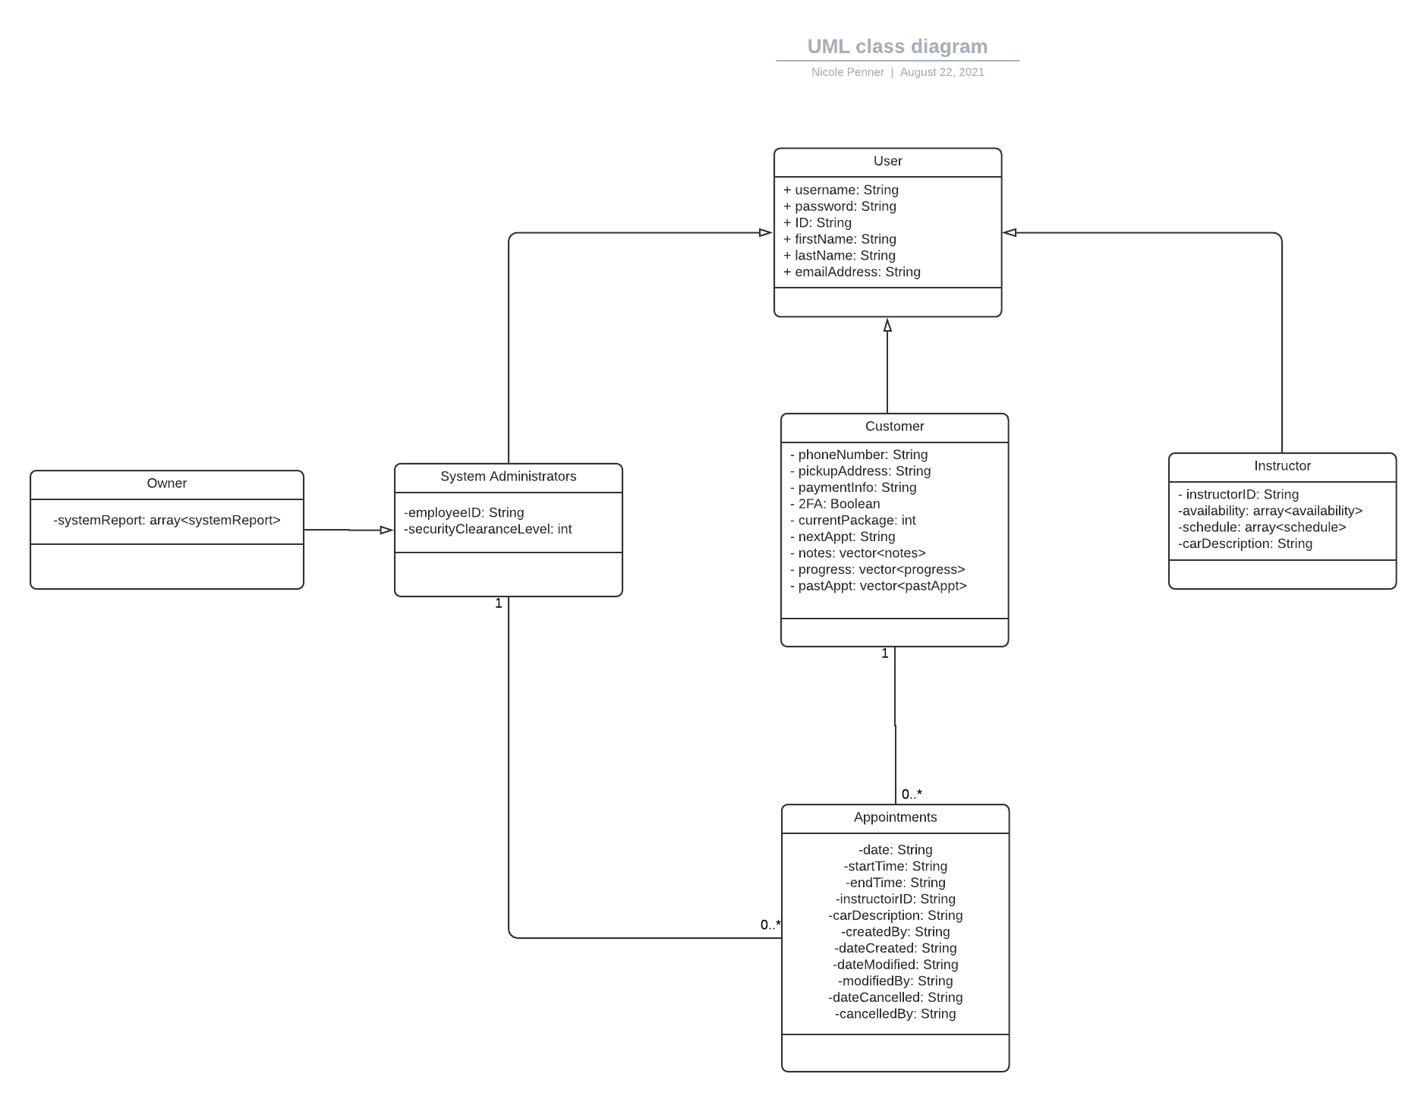

## Technical Requirements

A payment processing service will be needed. Since customers will have the option to choose and buy driving packages online, a payment service will need to be chosen to fulfill this functionality. A host machine that houses the backend database will be needed. This database will house user’s personal and sensitive data, like payment information and user account information. The host machine or site will need to be extremely secure so this sensitive data isn’t compromised. A computer will be needed to create the system, this includes a need for stable and consistent internet connection and an updated version of windows. The computer will need to have all software and programs necessary for the system design. The computer also needs to be capable of running these programs which means certain performance features need to be met. At the very minimum the computer should have an i5 processor and 8 GB of RAM, ideally higher performance components are preferred. A host site for the system will also need to be chosen based on the needs of DriverPass.